English

Hindi

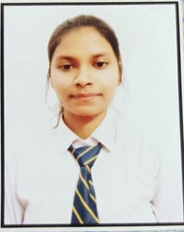

**SKILLS**

**SHIVANEE KUSHWAHA**

7800564730

shivaneekushwaha107

@gmail.com

**CONTACT**

Teamwork

**ABOUT MYSELF**

Time

Management

Leadership

Verbal & Written

communication

**LANGUAGE**

**EDUCATION**

**HighSchool (2016 - 2017)**

**Intermediate (2018-2019)**

**Skill Academy**

HTML5

CSS

**B.TECH (2019-2023)**

BRANCH- Electronic and communication

Rameshwaram Institute of Technology and Management,

AKTU

BRIC RAMPUR, POKHRAPAR, DEORIA

UP Board

SBSH'S SCHOOL BABHANI BHATNI

DEORIA

UP Board

**CERTIFICATES**

HTML, CSS & web development course completion

certificate

**PROJECTS**

**Home Automation Model**

Java Basic

|  |
| --- |
|  |

POINT

Problem Solving

C

https://www.linkedin.com/

in/shivanee-kushwaha-

5b2558268

Plot No 10 KH No 54 Jahirpur,

Lucknow, Uttar Pradesh, India

C++

**Land Mines Robot**

JavaScript